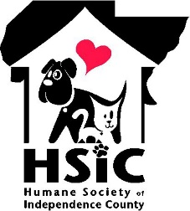 2024 Bark in the Park Vendor Information

Thank you in advance for your support of Bark in the Park!!
Our goal this year is to gain financial and community support of our mission to save abandoned, abused and neglected animals in Independence County and to emphasize the importance of spaying & neutering animals.

We need your support
We are asking each vendor partner to pay a small fee of $50 to participate this year. You may also donate an item valued at a min. of $50 if you prefer.

Your participation at this event will help draw people to the event! PLEASE help us advertise the event by sharing our HSIC posts and promote your participation. We would love to promote your participation, so sign up early! Ask your friends & family to also help us promote the event and your business.
Please display the flyer at your place of business.

Information you need
- The event will be held Saturday, June 15th at Riverside Park and Amphitheatre 10:30am – 2:30pm. Set up starts at 8:30 am
- Check in at Registration when you arrive to find out your assigned vendor booth location
- Please adequately staff your booth for the entire event
- Please do not start breaking down until we have ended the event on stage
- Vendors are responsible to provide their own tables, chairs, shade. signage etc…. It will most likely be a warm day, so please plan accordingly.
- Your dog(s) are welcome, but must be kept on a leash
- If you have images of items you will be selling and/or logos for your company, please send them to us at office@hsicshelter.org and we will help to promote your participation on our website and social media
- Most importantly, HAVE FUN and know that you are SO APPRECIATED!

Questions? Contact alicia.wood@southsideschools.org or office@hsicshelter.org

