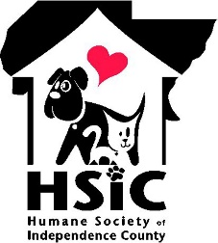 2024 Bark in the Park Sponsorship Form

Business Name: ________________________________________________________
Mailing Address: _______________________________ City: _________________ Zip _________
Contact Person: ______________________________________________
Phone: ________________________________ Email: _______________________________
Sponsorship Level:
____ Platinum $2500 ____ Silver $500
____ Diamond $1000 ____ Bronze $250
____ Gold $750 ____ Shelter Buddy $100
T-Shirt Sizes: Please see your sponsorship details to know how many you will be given)
No shirts Needed _____ Small _____ Med_____ Large _____ XL _____ XXL _____
Method of Payment:
______ Please accept my check Check No. ______
______ I have enclosed cash
______ Please bill my Credit Card (someone will call for the information)
______ I will use PayPal, CashApp, or Venmo to pay online. For these payment methods, use HSIC72501 and 7088 if it requests the last four digits of the telephone no. Please also indicate your chosen sponsorship level in the payment notes section for reference.
If mailing, please send to:
5 Environmental Drive Batesville, AR 72501
Office Use Only:
Date Entry Received: ________________________
Credit Card: _______________________________
Questions? Please contact Paula Stewart: 870.307.1064 or Anna Hogan: 870.793.6539

